8051 Micro Controller

The Atmel AT89 series is an Intel 8051-compatible family of 8 bit microcontrollers manufactured by the Atmel Corporation. Based on the Intel 8051 core, the AT89 series remains very popular as general purpose microcontrollers, due to their industry standard instruction set, and low unit cost. This allows a great amount of legacy code to be reused without modification in new applications. While considerably less powerful than the newer AT90 series of AVR microcontrollers, new product development has continued with the AT89 series for the aforementioned advantages. Of more recent times, the AT89 series has been augmented with 8051-cored special function microcontrollers, specifically in the areas of USB, I²C, SPI and CAN bus controllers, MP3 decoders and hardware PWM.

AT89 Series Microcontrollers

Device Name | Program Memory | Data Memory
AT89C1051 | 1K Flash | 64 Bytes RAM
AT89C2051 | 2K Flash | 128 Bytes RAM
AT89C51 | 4K Flash | 128 Bytes RAM
AT89C52 | 8K Flash | 256 Bytes RAM
AT89C55 | 20K Flash | 256 Bytes RAM
AT89S51 | 4K Flash | 128 Bytes RAM
AT89S52 | 8K Flash | 256 Bytes RAM
AT89S53 | 12K Flash | 256 Bytes RAM

AT89C51 Description

The AT89C51 is a low-power, high-performance CMOS 8-bit microcomputer with 4K bytes of Flash programmable and erasable read only memory (EPROM). The device is manufactured using Atmel’s high-density nonvolatile memory technology and is compatible with the industry-standard MCS-51 instruction set and pin out. The on-chip Flash allows the program memory to be reprogrammed in-system or by a conventional nonvolatile memory programmer. By combining a versatile 8-bit CPU with Flash on a monolithic chip, the Atmel AT89C51 is a powerful microcomputer which provides a highly-flexible and cost-effective solution to many embedded control applications.

Features of AT89C51

- Compatible with MCS-51 Products
- 4K Bytes of In-System Reprogrammable Flash Memory (Endurance: 1,000 Write/Erase Cycles)
- Fully Static Operation: 0 Hz to 24 MHz
- Three-level Program Memory Lock
- 128 x 8-bit Internal RAM
- 32 Programmable I/O Lines
- Two 16-bit Timer/Counters
- Six Interrupt Sources
- Programmable Serial Channel
- Low-power Idle and Power-down Modes

Pin Diagram of AT89C51

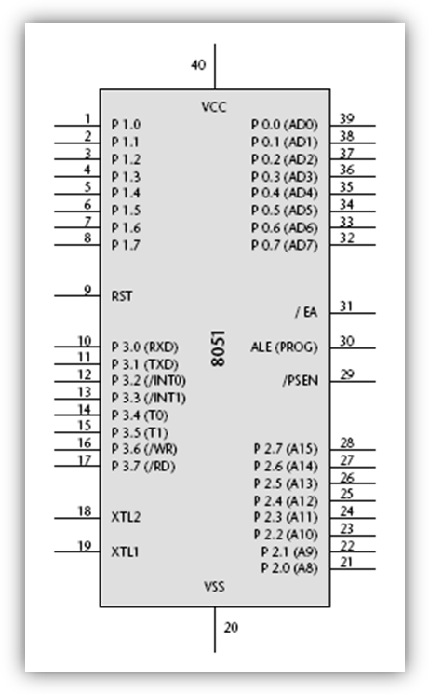

Basic Pins

PIN 9: PIN 9 is the reset pin which is used reset the microcontroller’s internal registers and ports upon starting up. A high on this pin for two machine cycles while the oscillator is running resets the device.
PINS 18 & 19: The 8051 has a built-in oscillator amplifier hence we need to only connect a crystal at these pins to provide clock pulses to the circuit.
PINS 40 and 20: Pins 40 and 20 are VCC and GND respectively. The 8051 chip needs +5V 500mA to function properly, although there are lower powered versions like the Atmel 2051 which is a scaled down version of the 8051 which runs on +3V.
PINS 29, 30 & 31: As described in the features of the 8051, this chip contains a built-in flash memory. In order to program this we need to supply a voltage of +12V at pin 31. If external memory is connected then PIN 31, also called EA (external access), should be connected to ground to indicate the presence of external memory. PIN 30 is called ALE (address latch enable), which is used when multiple memory chips are connected to the controller and only one of them needs to be selected. PIN 29 is called PSEN (program store enable). In order to use the external memory it is required to provide the low voltage (0) on both PSEN and EA pins.

Ports
All 8051 microcontrollers have 4 I/O ports each comprising 8 bits which can be configured as inputs or outputs. Accordingly, in total of 32 input/output pins enabling the microcontroller to be connected to peripheral devices are available for use.
Pin configuration, i.e. whether it is to be configured as an input (1) or an output (0), depends on its logic state. In order to configure a microcontroller pin as an output, it is necessary to apply a logic zero (0) to appropriate I/O port bit. In this case, voltage level on appropriate pin will be 0.
Similarly, in order to configure a microcontroller pin as an input, it is necessary to apply a logic one (1) to appropriate port. In this case, voltage level on appropriate pin will be +5V (as is the case with any TTL input).
PORT P1 (Pins 1 to 8): The port P1 is a general purpose input/output port which can be used for a variety of interfacing tasks. The other ports P0, P2 and P3 have dual roles or additional functions associated with them based upon the context of their usage.
PORT P3 (Pins 10 to 17): PORT P3 acts as a normal IO port, but port P3 has additional functions such as, serial transmit and receive pins, 2 external interrupt pins, 2 external counter inputs, read and write pins for memory access.
PORT P2 (pins 21 to 28): PORT P2 can also be used as a general purpose 8 bit port when no external memory is present, but if external memory access is required then port P2 will act as an address bus in conjunction with port P0 to access external memory. PORT P2 acts as A8-A15, as can be seen from pin diagram.
PORT P0 (pins 32 to 39) PORT P0 can be used as a general purpose 8 bit port when no external memory is present, but if external memory access is required then port P0 acts as a multiplexed address and data bus that can be used to access external memory in conjunction with PORT P2. P0 acts as AD0-AD7, as can be seen from pin diagram.

Memory Organization
The 8051 has two types of memory and these are Program Memory and Data Memory. Program Memory (ROM) is used to permanently save the program being executed, while Data Memory (RAM) is used for temporarily storing data and intermediate results created and used during the operation of the microcontroller. Depending on the model in use (we are still talking about the 8051 microcontroller family in general) at most a few KB of ROM and 128 or 256 bytes of RAM is used. However, all 8051 microcontrollers have a 16-bit addressing bus and are capable of addressing 64 KB memory.

Program Memory
The first models of the 8051 microcontroller family did not have internal program memory. It was added as an external separate chip. These models are recognizable by their label beginning with 803 (for example 8031 or 8032). All later models have a few KB ROM embedded. Even though such an amount of memory is sufficient for writing most of the programs, there are situations when it is necessary to use additional memory as well. How does the microcontroller handle external memory depend on the EA pin logic state:
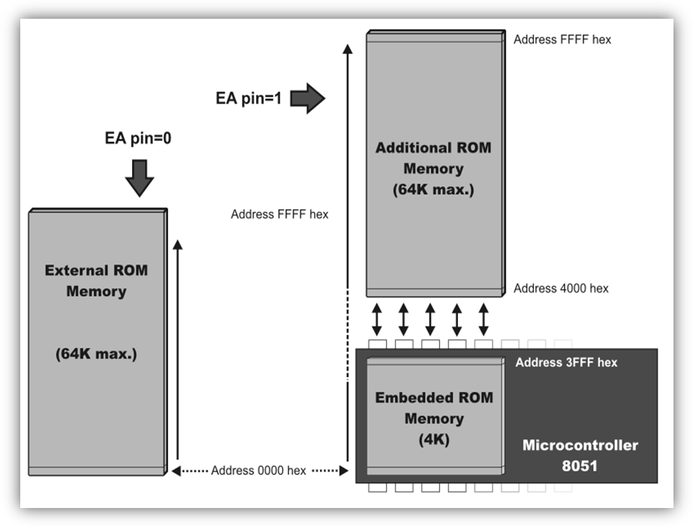
If EA = 0 then the microcontroller completely ignores internal program memory and executes only the program stored in external memory. If EA = 1 then the microcontroller executes first the program from built-in ROM, then the program stored in external memory. In both cases, P0 and P2 are not available for use since being used for data and address transmission. Besides, the ALE and PSEN pins are also used.
Data Memory
As already mentioned, Data Memory is used for temporarily storing data and intermediate results created and used during the operation of the microcontroller. Besides, RAM memory built in the 8051 family includes many registers such as hardware counters and timers, input/output ports, serial data buffers etc. The previous models had 256 RAM locations, while for the later models this number was incremented by additional 128 registers. However, the first 256 memory locations (addresses 0-FFh) are the heart of memory common to all the models belonging to the 8051 family. Locations available to the user occupy memory space with addresses 0-7Fh, i.e. first 128 registers. This part of RAM is divided in several blocks.
The first block consists of 4 banks each including 8 registers denoted by R0-R7. Prior to accessing any of these registers, it is necessary to select the bank containing it. The next memory block (address 20h-2Fh) is bit- addressable, which means that each bit has its own address (0-7Fh). Since there are 16 such registers, this block contains in total of 128 bits with separate addresses (address of bit 0 of the 20h byte is 0, while address of bit 7 of the 2Fh byte is 7Fh). The third group of registers occupies addresses 2Fh-7Fh, i.e. 80 locations, and does not have any special functions or features.

Special Function Registers (SFRs)

Special Function Registers (SFRs) are a sort of control table used for running and monitoring the operation of the microcontroller. Each of these registers as well as each bit they include, has its name, address in the scope of RAM and precisely defined purpose such as timer control, interrupt control, serial communication control etc. Even though there are 128 memory locations intended to be occupied by them, the basic core, shared by all types of 8051 microcontrollers, has only 21 such registers. The rest of locations are intentionally left unoccupied in order to enable the manufacturers to further develop microcontrollers keeping them compatible with the previous versions. It also enables programs written a long time ago for microcontrollers which are out of production now to be used today.

Additional RAM
In order to satisfy the programmers’ constant hunger for Data Memory, the manufacturers decided to embed an additional memory block of 128 locations into the latest versions of the 8051 microcontrollers. However, it’s not as simple as it seems to be… The problem is that electronics performing addressing has 1 byte (8 bits) on disposal and is capable of reaching only the first 256 locations, therefore. In order to keep already existing 8-bit architecture and compatibility with other existing models a small trick was done.
What does it mean? It means that additional memory block shares the same addresses with locations intended for the SFRs (80h- FFh). In order to differentiate between these two physically separated memory spaces, different ways of addressing are used. The SFRs memory locations are accessed by direct addressing, while additional RAM memory locations are accessed by indirect addressing.
